Tutorial for Radar Signal Processing and DoA Estimation

Tseng Tzu-Jung
revised by Jian-Jiun Ding

Graduate Institute of Communication Engineering
National Taiwan University

February, 2023

Outline
Outline 2
1. Introduction 3
2. Fundamental Radar systems with recent devices 4
2.1 Pulse radar 5
2.2 Continuous wave radar 6
2.3 Frequency-Modulated Continuous Wave radar 9
2.4 MIMO radar 15
3. Radar and Direction of arrival 16
3.1 Beamforming Techniques 17
3.1.1 Capon’s Beamformer 18
3.2 Maximum Likelihood (ML) Techniques 19
3.3 Subspace-Based Techniques 20
3.3.1 MUSIC 21
3.3.2 ESPRIT 23
3.4 Compressive sensing 26
4. Conclusion 30
References 31

Introduction
The word "RADAR" stands for "radio detection and ranging." Nowadays, since it is widely used, the word radar has become a standard noun. With radar, we could obtain the pieces of information about the target, such as relative distance, velocity, and shape, by receiving the power that was reflected from the target. This technology can be utilized in various kinds of circumstances, for example, space surveillance, military, remote sensing, and biomedical imaging.
In history, radar was not in high demand until 1930 during WWII. At that time, radar-related research developed rapidly, and countries developed this technology to gain advantages in warfare in harsh environments. Radar was mainly used for detecting aircrafts or battle ships under poor vision conditions, for example, in the dark or heavy fog. Although it was first made for wars, people continue to develop radar technology and have used it in many inventions that benefit people’s lives after warfare. In recent years, radar sensors come in different structures, and due to the improvement of IC packaging, the frequency of the radar can become higher for more precise detections.
This paper is divided as follows. Section 2 describes the modern radar system devices with their basic signal processing and applications. The processing to extract the direction of arrival (DoA) is given in Section 3 with some currently used angle estimation techniques. Furthermore, the main conclusions are offered in Section 4.

Fundamental Radar systems with recent devices
Radar is designed for detecting, locating, characterizing, etc. With a wide variety of radar platforms and targets, each radar is used for different practical applications. Radar systems consist of three major subsystems: the transmitter, the receiver, and the signal processing subsystems, as shown in Figure 2.1. The transmitter subsystem works as the source signal. The ranging capabilities of the radar are mainly determined by the transmitter, which will be discussed later in this chapter. And the receiver subsystem receives the reflected signal. Moreover, the signal processing subsystems apply different kinds of algorithms to extract the signal for determining the parameters of the targets under some noise distortion during transmitting to receiving processing or to decrease the effectiveness of the hardware structure limitation.

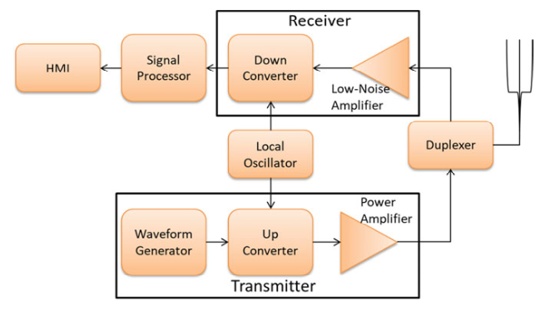
Figure 2.1: Components of a simplified radar system [1].

Based on the waveform of the transmitting signal, it can be divided into two categories, pulse radar, and continuous wave radar. If the continuous wave radar signal is frequency modulated, it is called frequency modulated continuous wave radar. Moreover, based on the number of transmit antennas for one radar system, there are MIMO radar and massive MIMO radar systems. In this chapter, the radar models will be introduced sequentially with their signal representations, how they can be utilized, and their current applications.

Pulse radar
Pulse radar is a radar system that sends out powerful single pulses or signals that consider multiple bursts to get the range to the target. Meanwhile, the transmitter is turned off before the measurement is finished. Based on the time delay, the pulse radar can decide whether there is a target in front of it.

- 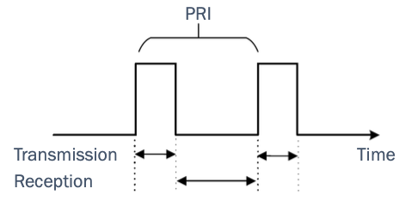
- Figure 2.2: PRI pulse radar system [2].

- Target distance $R$ can be calculated by measuring the time duration $Δt$ when the pulse is transmitted from the radar to the target and returned to the radar. Hence electromagnetic waves travel at a light speed $c=3×{10}^{8}m/s$, the target distance $R$ can be formed as
$R=\frac{cΔt}{2}$ (2.1)
- Regarding the range resolution, the word pulse repetition frequency (PRF) must be introduced first. As shown in Figure 2.2, the pulse radar only does one task at a time, either emitting the pulse wave or listening for the echo signal. Therefore, pulse repetition interval (PRI) is the cycle between pulses, and pulse repetition frequency indicates the number of pulses transmitting over a second. Consider that if emitting the second signal after receiving the wave, there will be no ambiguity range as the reflected pulse can be easily identified as a reflection of the first pulse. However, suppose another target at a further distance causes the second received wave after the second pulse is sent. In that case, it will cause some confusion since the radar cannot determine whether the received signal is an echo of the first or second pulse. The above situation is an ambiguity in determining the range. Hence, the maximum unambiguous range $R_{max}$ is
$R_{max}=\frac{c}{2PRF}$ (2.2)
- Due to its broadband nature, pulse radar is unfavorable in commercial low-power operations. Its application is mainly in the military, such as through-wall imaging radar and other long distances target detection, such as weather observation, satellite-based remote sensing, etc.

Continuous wave radar
With the development of the detection technique, people found out that distance detection is not enough; therefore, researchers try to base on the frequency difference between the received echo signal and transmitted signal to fetch the information of the target velocity, which is also the idea of the Doppler effect. Since it uses Doppler frequency to compute the velocity, it is also called the Doppler radar. The signal’s echo can determine the properties of the target. For example, the size of the target can is depended on the amplitude of the signal since with a bigger reflection area; the reflection signal is also larger. Moreover, if the target is away from the radar, the signal sign differs from moving close to the radar.
Continuous radar transmitted wave $s_{t}\left(t\right)$ can be seen as a pure tone of $cos2πf_{0}$ sinusoidal wave signal and can be described as
$s_{t}\left(t\right)=A\left(t\right)cos\left(ω_{0}t+ψ\right)$ (2.3)
- where the function $A\left(t\right)$ is the signal’s amplitude, $ω_{0}$ is the angular frequency of the transmitted signal, and initial phase $ψ$. And the received signal is
$s_{r}\left(t\right)=ks_{t}\left(t-t_{r}\right)=kA\left(t\right)cos\left(ω_{0}\left(t-t_{r}\right)+ψ\right)$ (2.4)
- with $t_{r}$ is the time duration from transmitted to received, $k$ as received signal attenuation coefficient.

- 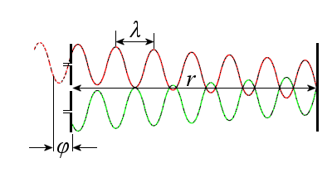
- Figure 2.3: The phase shift of CW radar [3].

- The CW radar calculates the phase difference $ϕ\left(t\right)$ between the transmitted and the received. As shown in the Figure 2.3, if the target is moving, $ϕ$ is the ration of the distance traveled $r$ and the wavelength $λ$ of the emitted signal, and multiplied by $4π$, which is written as
$ϕ_{0}=4π\frac{r}{λ}$ (2.5)
- With equation (2.5), the phase difference between the first received signal from the first emitted signal and the first received signal from the second emitted signal can be written as
$Δϕ=\frac{4πΔr}{λ}=\frac{4πvT_{c}}{λ}$ (2.6)
- where $T_{c}$ is the time duration of the above situation, $v$ is the target velocity. Hence, the velocity calculated with a phase difference is represented as
$v=\frac{λΔϕ}{4πT_{c}}$ (2.7)
- CW radar is preferred in the market since the advantage of mobility and portable applications. CW radars have been used in many circumstances. For example, in 2017, an investment in using CW radar systems as a sphygmograph and compared with a synchronous laser-based as a reference, and the result found that the result is ensured [4]. Toomajian and his team investigated a 5.8 GHz CW-based convolutional neural network system using micro-Doppler signatures to improve hand gesture recognition [5]. The experiment results for ten gestures were found to be 85.6%; meanwhile, with seven gestures, the accuracy increased to 93.1%. Harbin institute of technology university also presented a hand gesture system with 24 GHz CW radar. Gesture motions like hand pushing, hand pulling, hand lifting, and hand shaking have accuracy rates of more than 92% [6].

- 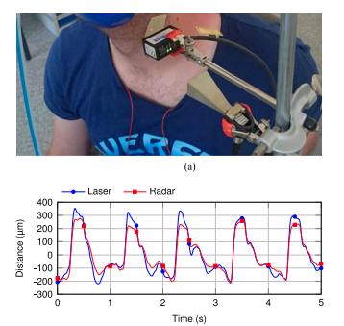  - (a)CW radar for vital signs [4]. | - 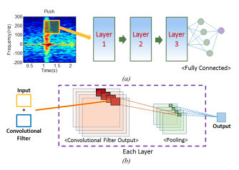  - (b)5.8 GHz CW radar in hand gesture recognition [5]. | - 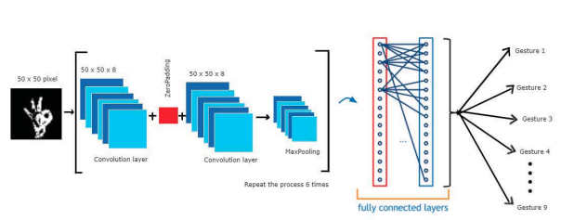  - (c)24 GHz in hand gesture recognition [6].
- Figure 2.4: Applications of CW radar.

- CW radars can be used in many relative velocity measurements, such as car speed detection and motion monitoring. Also, it is small and easy to construct. However, CW radar can measure the speed only using the Doppler effect, as it cannot detect any stationary target. Also, it cannot measure the range or tell the difference between two or more objects.

Frequency-Modulated Continuous Wave radar
Frequency-modulated continuous wave radar, short for FMCW radar, is an extension of CW radar that can adjust the operating frequency. Its architecture is shown in Figure 2.5. FMCW radar can detect distance by the phase difference between transmit’s and receive’s phases, and based on doppler frequency to detect velocity. Aside from emitting the single-tone frequency, FMCW sends frequency-shifting waves, such as chirp waves, triangle waves, or sawtooth waves.

- 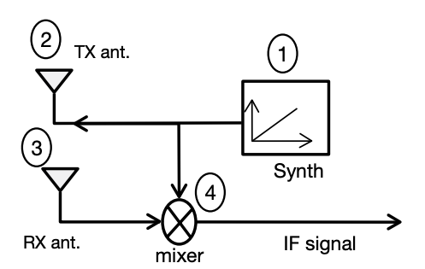
- Figure 2.5 The block diagram of FMCW radar [7].

- 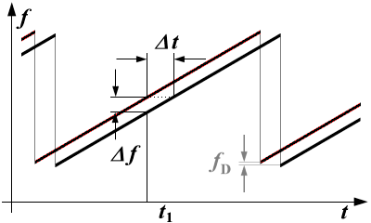
- Figure 2.6 Ranging with an FMCW system [8].

- Take chirp waves, for example, and denote $Δf$ as the signal mixing the received signal frequency with the transmitted frequency. This frequency difference is also called the “beat frequency.” The beat frequency is a function of the round-trip delay, it can be mapped to the range domain, and the spectrum will peak the object range location. Therefore, the distance $d$ can be calculated by the following formula,
$d=\frac{cΔfT}{2BW}$ (2.8)
- where $T$ represented as the sweep time, and $BW$ as the bandwidth of the chirp. To estimate $Δf$, a fast Fourier transform (FFT) is used in the fast time domain, which depends on the sampling rate frequency. Since it resolves objects in range, it is called "range-FFT." Moreover, the resolution of the range solution $d_{res}$ is written as
$d_{res}=\frac{c}{2B}$ (2.9)
- where $B$ is the bandwidth of the chirp. Therefore, using a wider bandwidth lead to a smaller minimum range error. However, the maximum detection range $d_{max}$ is not unlimited; in fact, it is based on the frequency tone $F_{s}$, which is the sampling rate and the slope of the chirp, with the equation written as,
$d_{max}=\frac{cF_{s}}{2S}$ (2.10)
- The receiver system received not only the frequency difference for the distance computation but also measured the Doppler frequency, which is used for calculating the object’s velocity $v$. The target motion will cause a phase shift over the transmit signal and is used for velocity computation written as
$v=\frac{λf_{D}}{2}$ (2.11)
- where the $λ$ is the wavelength of the CW signal, and $f_{D}$ is the Doppler frequency. If the target is getting close to the radar, the frequency increases from the frequency of received signal $f_{r}$ adding additional $f_{D}$, which is $f_{r}+f_{D}$. On the other hand, if moving further away, then the frequency is $f_{r}-f_{D}$. An FFT is mostly used across chirps to estimate phased shift and then transform it to velocity estimation; therefore, it is also called a "velocity FFT." In the previous paragraph, range resolution and boundaries have been discussed; there is a velocity resolution and the maximum value, likewise. The velocity resolution is written as
$v_{res}=\frac{λ}{2NT_{c}}$ (2.12)
- where N is the collected number of chirps. With equation (2.11) and since $\left|Δϕ\right|<π$, the maximum velocity detection $v_{max}$ is represented as
$v_{max}=\frac{λ}{4T_{c}}$ (2.13)
- By processing the receiver array signal composed of multiple elements, FMCW radar enables azimuth localization of the target, which means the angle of arrival can also be determined. From Figure 2.7(a), when the object reflected signal reflects to two different receivers, there exists some time delay since there is an extra distance $Δd$ for the wavefront to reach $RX_{2}$. This $Δd$ further causes two receiving signals have a phase shift $Δϕ$ with
$Δϕ=\frac{2πΔd}{λ}$ (2.14)

- 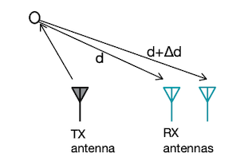  - (a)Differential distance from the object to each of the antennas. | - 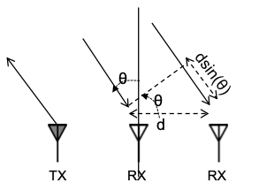  - (b)Differential distance based on the DoA angle.
- Figure 2.7: Two antennas for estimating DoA [7].

- Figure 2.7(b) further discussed if the distance between $RX_{1}$ and $RX_{2}$ is determined with $L$. Then $Δd=L×sin\left(θ\right)$, with equation (2.14) be written as
$θ=sin^{-1}\left(\frac{λΔϕ}{2πL}\right)$ (2.15)
- An FFT across receivers called an "angle FFT," can also resolve objects with their arrival angles since the echo from a target can result in the steering vector as the array output. The angle resolution $θ_{res}$ is based on the phase difference with $Δω>\frac{2π}{N}$, and it can be written as
$θ_{res}=\frac{λ}{NLcos\left(θ\right)}\frac{{180}^{∘}}{π}=\frac{2}{N}\frac{{180}^{∘}}{π}$ (2.16)
- Based on the exact condition similar to equation (2.13), with $\left|Δϕ\right|<π$, the maximum angular can be represented as
$θ_{max}=sin^{-1}\left(\frac{λ}{2L}\right)$ (2.17)
- Since the relation between phase difference $Δϕ$ and the angle of arrival $θ$ is nonlinear when the target’s arrival angle increase to ${45}^{∘}$, the probability of miscalculating the angle increases.
- There are some applications of FMCW radar. Texas Instruments Incorporated proposed a paper about using an FMCW mmWave sensor to demonstrate vital signs and have promising results [9]. Also, in 2019, Safavi-Naeini and his team developed a mmWave FMCW radar for patients to be in bed and extract the respiration and heart rate [10]. Changzhi Li and his team had designed a 5.8-GHz FMCW radar for hand gestures with multiple targets and with the technique of time-frequency micro-Doppler and range-Doppler processing to prove the feasibility of further hand gesture development [11]. Also, Chongqing University of Posts and Telecommunications proposed a hand gesture recognition based on an FMCW range-doppler map and a time sequential inflated three dimensions (TS-I3D) convolutional neural network to extract the variation of range and speed in the continuous gestures. Moreover, the result has an average recognition accuracy rate of 96.17% of the hand gestures [12].

- 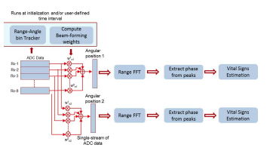 | - 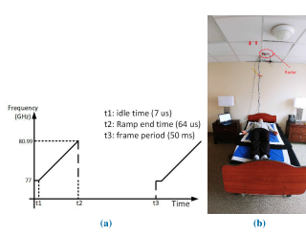
- (a)Texas Instruments Incorporated proposed FMCW radar [9] . | - (b)FMCW radar for extracting the respiration and heart rate [10] .
- 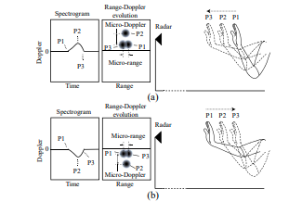 | - 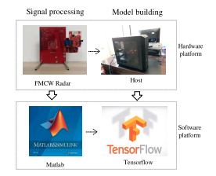
- (c)5.8 GHz FMCW radar in hand gesture recognition [11] . | - (d)FMCW radar for continuous gestures [12] .
- Figure 2.8: Applications of FMCW radar

- While pulse radar and CW radar can measure the distance and velocity, FMCW radar can detect both the range and velocity of the target. However, there is some trade-off between the targets’ range and velocity accuracy. Hence, the waveform is different for different purposes. For example, when detecting the target, high PRF is used to get a more accurate target velocity; on the other hand, when tracking, because high PRF has an ambiguous range value, low PRF is used for finding the location of the target.

MIMO radar
Besides the parameter of distance and velocity, the direction of arrival is also a crucial value when detecting an object. The above paragraphs give a take on radar structure primarily based on one transmitter radio frequency (TX) to multiple receiver radio frequency (RX). However, the angle resolution from FMCW radar could be better. Therefore, a system called multiple-input-multiple-output radar (MIMO radar) is designed to improve the such situation. They offer a more significant number of virtual antenna elements, which reduces the hardware effort. For example, if there exists a number of N TX and M RX, the equation (2.16) can be written as
$θ_{res}=\frac{λ}{N_{TX}M_{RX}×Lcos\left(θ\right)}\frac{{180}^{∘}}{π}$ (2.18)
- Mostly, the number of antennas in MIMO radar is no more than eight; if the number is more than 100, it is called the "massive MIMO" or large-scale MIMO. This kind of radar is used in the 5G and has a higher efficiency and resolution than the MIMO. Meanwhile, the technique’s development is still undergoing with the arrangement and calibration of the antenna pattern, establishing the communication channels, and combining signal processing algorithmic Technologies.
- With the improvement of the spatial diversity and angle resolution, the application, people expect MIMO radar can be used to help improve human life and has become one of the most used radars recently. One of the most popular usages, Soli, was introduced by Google ATAP. They promoted gesture sensing with millimeter-wave radar using random forests and Bayesian filter techniques, and each has an accuracy of 86.90% and 92.10% over 308,335 test samples [13]. In 2020, Dr. Hou and his team published a continuous gesture recognition using MIMO radar at Central South University in China. With a range FFT-based MUSIC (RFBM) and some other parameter joint maps as inputs of a dual stream three-dimensional convolution neural network. And combined with long short-term memory (DS-3DCNN-LSTM) network, the experimental results show that they can distinguish ten types of gestures with an average accuracy of 97.66% [14]. Static hand gesture classification using a sterile training technique proposed by Dr. Torlak and his team. With the novel method, deep CNN training can be improved and thus increase in classification rate from 85% to 93% and 90% to 95% for range and range-angle profiles, respectively [15].

- (a)Soli with gesture sensing [13]. | - (b)MIMO with CNN-LSTM [14] . | - 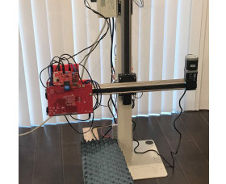  - (c) MIMO with deep CNN training [15].
- Figure 2.9: Applications of MIMO radar

Radar and Direction of arrival
When detecting targets, from the previous chapter, it knows that we can have the information about the distance between radar and target with pulse and CW radar for the target’s velocity. In contrast, FMCW and MIMO radar can obtain relative distance and velocity. The above techniques can be easily used by applying Fourier transformation with a single target. When it comes to multiple targets, things get more complicated if we want to separate them since they could have the same value of distance and velocity. However, with the help of direction of arrival (DoA), we could solve the angles where different targets are situated and separate them.
DoA is a parameter for a more detailed target explanation. With the information of DoA, the degrees of the signals reflected targets signals can be known; therefore, the angles of the targets are found since DoA can also be the short-term degrees of angles in this situation. The application of DoA is wide, for example, in communication, acoustics, surveillance, radars, and others.
The previous chapter introduced two easy methods to compute the target angle. However, their resolutions are poor due to the limitation of the antenna number. Therefore, researchers tend to resolve the problem by estimating a more precise angle. According to "Introduction to Direction-of-Arrival Estimation," by Zhizhang Chen and his team, DoA can be divided into three categories: beamforming, maximum likelihood, and subspace-based [16]. However, with the innovation of the calculation techniques, some novel methods like compressive sensing have also been utilized in this field specified in solving sparse signals. Therefore, in this tutorial, DoA will be classified into four types, adding Compressive sensing as a respective group of the DoA method and with some popular classic techniques as examples.

Beamforming Techniques
A beamforming signal processing technique is often used when transmitting a directional signal using a sensor array. Usually, the antenna transmits a signal without a particular design, is omnidirectional, and spreads out in multiple directions. By forming the radar signal to be constructive in particular degrees while destructive in others. With the technique of steering the array radar, the maximum output power will be observed when the DoA of a signal equals the steered angle.
- While implementing the beamforming method, a weight vector $w$ needed to be considered as the steering vector, which can be used to do linear combination with the signal $x\left(t\right)$, in order to reform an output signal $y\left(t\right)$ radar pattern and its orientation,
$y\left(t\right)=w^{H}x\left(t\right)$ (3.1)
- With the autocorrelation of $x\left(t\right)$ written as ${\hat{R}}_{xx}$, the total output power represented as
$P\left(w\right)=Σ{\left|y\left(t\right)\right|}^{2}=w^{H}{\hat{R}}_{xx}w$ (3.2)
- Hence, the beamforming method is to estimate the angle by measuring the maximum output power $P\left(w\right)$ choosing a different steering vector $w$. In the following section, an easy technique called Capon’s beamformer is discussed.

Capon’s Beamformer
Based on the beamforming technique, Capon’s method uses degrees of freedom to form a beam in all possible directions. The target of this method is to maintain constant gain for signals arriving from a specific direction while giving smaller weight to noise. The power formed with a distinct look angle $θ$ is observed and constrained the gain to be one while using the remaining degrees to minimize the output power coming from other directions. Therefore, the method can be stated as a constrained minimization optimization problem as fellow:
$\min_{w} w^{H}{\hat{R}}_{xx}w \text{subject to} w^{H}a\left(θ\right)=1$ (3.3)
  - and the received power spectrum is
$P_{MVDR}\left(θ\right)=\frac{1}{a^{H}\left(θ\right){\hat{R}}_{xx}^{-1}a\left(θ\right)}$ (3.4)
  - where $a\left(θ\right)$ is the steering vector storing different scanning angle $θ$. The way the weight vector is chosen is often referred to the minimum variance distortionless response (MVDR) beamformer since it minimizes the average power, which is also the variance of the output signal, while passing the signal at the look angle distortionless. The Capon’s beamformer procedure is shown in Algorithm 1.
  - 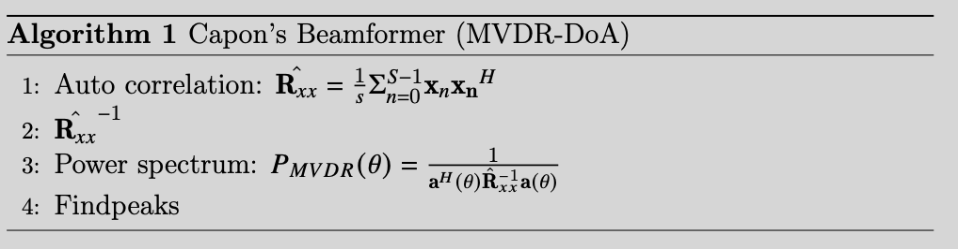
  - This technique is easy to implement and performs well in resolving closely spaced targets. Moreover, it does not require prior knowledge of the number of signal sources. Nevertheless, it is limited by SNR and receiver array size and has a disadvantage with poor resolution. Also, determining the inverse of a nearly-singular covariance matrix is not trivial in the real world. Although the narrowing beam can solve poor resolution, the extensive computation of the inverse matrix will become another problem needed to be solved.

Maximum Likelihood (ML) Techniques
ML techniques perform better than other estimators, especially in low SNR circumstances. Denote that the received signal is $x\left(t\right)$ and signal components are $A\left(θ\right)s\left(t\right)$, then the technique is to subtract from $x\left(t\right)$ an estimated $A\left(\hat{θ}\right)\hat{s}\left(t\right)$. The performance is based on the residual $x\left(t\right)-A\left(\hat{θ}\right)\hat{s}\left(t\right)$; therefore, the result will be closer to the ground truth by minimizing power in the residual, which can be written as
$\min_{θ,\hat{s}\left(t\right)} <||x\left(t\right)-A\left(\hat{θ}\right)\hat{S}\left(t\right){||}^{2}>_{N}$ (3.5)
- After some mathematical manipulations, Equation (3.5) is equivalent to
$\max_{\hat{θ}} trace\{P_{A}\left(\hat{θ}\right)R_{xx}\}$ (3.6)
- where matrix $P_{A}\left(\hat{θ}\right)$ is the space spanned by $A\left(\hat{θ}\right)$. If $\hat{θ}$ is the exact solution, then the reconstructed data $A\left(\hat{θ}\right)\hat{S}\left(n\right)$ is equal to the ground truth signal plus the noise,
$\begin{matrix}X\left(n\right)-A\left(\hat{θ}\right)\hat{S}\left(n\right) & =X\left(n\right)-P_{A}\left(\hat{θ}\right)X\left(n\right) \\ & =\left(A\left(\hat{θ}\right)\hat{S}\left(n\right)+N\right)-\left(A\left(\hat{θ}\right)\hat{S}\left(n\right)+P_{A}\left(\hat{θ}\right)N\right) \\ & =\left(I-P_{A}\left(\hat{θ}\right)\right)N\end{matrix}$ (3.7)
- ML techniques were some of the first methods for DoA estimation. However, with the intense computation of ML techniques, they are less popular among other DoA techniques.

Subspace-Based Techniques
The subspace-based techniques are based on using the eigen-structure of the data covariance matrix. Assume the received signals matrix by one receive antenna is $x\left(t\right)$ of size $M×1$ are combined with transmission signals matrix $s\left(t\right)∈C^{d×1}$, and noise $n\left(t\right)∈C^{M×1}$. Then received signals matrix at time $t$ can be written as
$x\left(t\right)=A\left(θ\right)s\left(t\right)+n\left(t\right)$ (3.8)
- where $A\left(θ\right)∈C^{m×1}$ is the steering matrix.
- Since the signals and the noise are uncorrelated, the array output covariance matrix is
$R_{xx}=E\{x\left(t\right)x^{H}\left(t\right)\}=A\left(θ\right)R_{ss}A^{H}\left(θ\right)+σ_{n}^{2}I_{M}$ (3.9)
- where $R_{ss}$ is the signal correlation matrix, $σ_{n}^{2}$ is the noise variance, and $I_{M}$ is the rank $M$ identity matrix. Next, suppose $d≤M$, and then by the eigen-decomposition method, the equation can be presented as
$R_{xx}=Σ_{k=1}^{M}λ_{k}e_{k}e_{k}^{H}$ (3.10)
- where eigenvalues $λ_{k}$ are sorted from largest to smallest with the smallest value being $σ^{2}$, and the $e_{k}$ are the corresponding eigenvectors.
- The subspace-based method is based on using the idea that the matrix space of $R_{xx}$ is spanned by the eigenvectors $E_{s}$ and $E_{n}$, where the signal subspace is spanned by eigenvectors with larger eigenvalues, and the noise subspace is spanned with smaller eigenvalues of the correlation matrix.
- Take the MUSIC algorithm as an example; the relation of $λ_{k}$ can be written as $λ_{1}≤…≤λ_{d}<λ_{d+1}=…=λ_{M}=σ^{2}$. Let $U_{s}=\left[e_{1}…e_{d}\right]$ be the signal eigenvectors, and $U_{n}=\left[e_{d+1}…e_{M}\right]$ be the noise eigenvectors. Then the range of the $U_{s}$ is the signal subspace, and $U_{n}$ is the noise subspace. The details will be explained in the following section.
- In the next sections will be introducing two revolutionary methods, which are Multiple Signal Classification (MUSIC) and Estimation of Signal Parameters via Rotational Invariance Techniques (ESPRIT).

MUSIC
MUSIC was proposed in 1979 by Schmidt [17]. It is based on a subspace decomposition method and assumes that the signal is orthogonal to noise. This DoA estimation method searches through all the possible steering vectors and finds the signal orthogonal to the noises. It has superior resolution capabilities compared to beamforming methods mentioned in Chap. 3.1. Since it has a high resolution, MUSIC has been widely used.
  - By the MUSIC assumption, ideally, the subspace of the signal is orthogonal to the subspace of noise, that is the steering vector of signal $a^{H}\left(θ\right)$ is orthogonal to noise’s subspace,
$a{\left(θ\right)}^{H}U_{N}=0$ (3.11)
  - where $a\left(θ\right)$ is an element of matrix A with $A=\left[a\left(θ_{1}\right)…a\left(θ_{M}\right)\right]$ .
  - This assumption forms almost all of the subspace-based technology. It means that estimating the received signals’ steering vectors can be done by finding the steering vectors orthogonal to the $R_{xx}$ last $M-d$ eigenvectors that are equal to $σ^{2}$.
  - Therefore, by letting the signal eigenvector $E_{s}$ corresponding eigenvalue matrix is $Σ_{s}=diag\left(λ_{1},…,λ_{d}\right)$, and $Σ_{n}=diag\left(λ_{d+1},…,λ_{M}\right)$ be the corresponding eigenvalues of the noise eigenvectors. Then the Equation (3.9) can be represented as
$$R_{xx}=U_{s}Σ_{s}U_{s}^{H}+U_{n}Σ_{n}U_{n}^{H}=UΣU^{H}$$
with $U_{x}=\left[U_{s},U_{n}\right]$ and $Σ_{x}=diag\left(λ_{1},…,λ_{M}\right)$ (3.12)
  - Then the MUSIC spectrum is
$P_{MUSIC}\left(θ\right)=\frac{1}{a^{H}\left(θ\right)U_{n}U_{n}^{H}a\left(θ\right)}$ (3.13)
  - Since the signal and the noise is uncorrelated, the product will be zero. Therefore, the fraction will have the maximum peak at the target angle.
  - 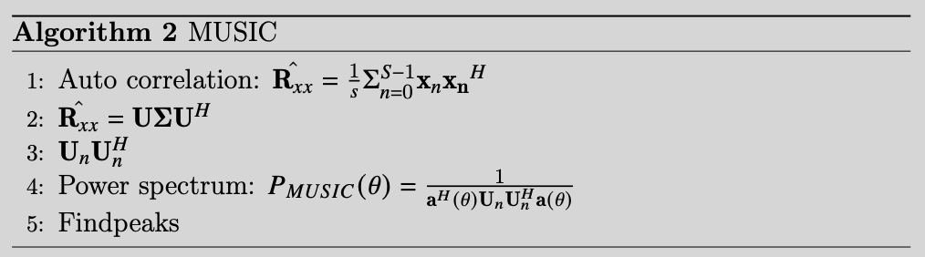
  - The technique is one of the high-resolution techniques with angular separation close to $1∘$ and is useful when the signal has a low rank of noise. By increasing the number of snapshots used for spectrum estimation, the ability of MUSIC to separate multiple targets can be further improved. However, MUSIC is often complicated by the fact that there will be multiple and unknown numbers of source signals, which requires prior knowledge of the size of the signal subspace. Also, the eigen-decomposition process in MUSIC requires high computational complexity, which is not suitable for real-time signal processing.

ESPRIT
Another widely used subspace-based DoA estimation is called ESPRIT. It was proposed by Dr. Roy and his team in 1986. While MUSIC uses the noise subspace, ESPRIT forms the signal subspace with a rotation variance technique in conjunction without using nonlinear optimization like the beamforming method. Based on the fact that the signals arriving at the second element will experience an extra delay due to the fixed displacement $Δ$ between the two elements, which is not greater than $\frac{1}{2λ}$. Let $x_{1}$ and $x_{2}$ represent the signal received by the two elements with additive noise $n_{1}\left(t\right)$ and $n_{2}\left(t\right)$. And with $A$ as the steering matrix of the subarray, the subsets hold the following equations,
$x_{1}\left(t\right)=As\left(t\right)+n_{1}\left(t\right)$ (3.14)
$x_{2}\left(t\right)=AΦs\left(t\right)+n_{2}\left(t\right)$ (3.15)
  - where $Φ=diag\left(e^{-jϕ},…,e^{-jϕ_{M}}\right)$ is a diagonal matrix that relates the signals received by the two subarrays.
  - Because the signals arriving at the second subarray will have an extra delay due to the displacement $Δ$ between the subarrays, the diagonal matrix can also be called as the rotation matrix; where the spatial frequency $ϕ_{i}=-\frac{2π}{λ}Δsin\left(θ_{i}\right)$, for $1≤i≤d$. From Equation (3.14) and (3.15) can be combined into a total output vector $x\left(t\right)$ as
$x\left(t\right)=\left[\begin{matrix}x_{1} \\ x_{2}\end{matrix}\right]=\left[\begin{matrix}A \\ AΦ \end{matrix}\right]s\left(t\right)+\left[\begin{matrix}n_{1}\left(t\right) \\ n_{2}\left(t\right)\end{matrix}\right]=\tilde{A}s\left(t\right)+n\left(t\right)$ (3.16)
  - The objective of ESPRIT is to estimate the $ϕ_{i}$ for estimating the DoAs.This technique requires two main steps based on the array received data: estimate the signal subspace and the subspace rotation operator $Φ$. Assume that the signal is ideal noise-free, then the autocorrelation similar to (3.6) is formed as
$R_{xx}=E\{x\left(t\right)x^{H}\left(t\right)\}=\tilde{A}R_{xx}\tilde{A^{H}}$ (3.17)
  - where both $R_{xx}$ and $\tilde{A}$ are assumed to have full rank $d$.
  - Suppose that the signal subspace is spanned as $E=\left[e_{1},…,e_{d}\right]$. Since $R_{xx}$ has full rank, $E$ and $\tilde{A}$ span the same space. Therefore, there is a unique nonsingular matrix $T$ that represents as $E=\tilde{A}T$. Assume that the signal is ideal noise-free, then the autocorrelation is similar to (3.6) and $E$ can be written as
$E=\left[\begin{matrix}AT \\ AΦT\end{matrix}\right]=\left[\begin{matrix}E_{1} \\ E_{2}\end{matrix}\right]$ (3.18)
  - where $E_{1}$ and $E_{2}$ are represented as the two subarrays. And Range$\{E_{1}\}$=Range$\{E_{2}\}$=Range$\{A\}$, which means that the two subarrays span the same subspace and have the same dimension. Furthermore, a nonsingular $d×d$ matrix denoted as $Ψ$ can be written as
$E_{1}Ψ=E_{2}$ (3.19)
  - then with $\tilde{A}$ in equation (3.15)
$Ψ=T^{-1}ΦT$ (3.20)
  - In equation (3.19), $Ψ$ and $Φ$ are similar, also, $Φ$ can be seen as the eigenvalue of $Ψ$ that maps the $E_{1}$ and $E_{2}$ with the first and second subarray. So, instead of directly finding the spatial rotational $Φ$, the ESPRIT technique finds the subspace rotating operator $Ψ$ and then finds its eigenvalues by the eigen-decomposition method.
  - However, in reality, the signal $x\left(t\right)$ is considered to have some level of noise. Then the covariance matrix $R_{xx}=\tilde{A}R_{ss}{\tilde{A}}^{H}+σ_{n}^{2}I$. Furthermore, Range$\{E\}≠$Range$\{A\}$ and Range$\{E_{1}\}≠$Range$\{E_{2}\}$, and equation (3.18) can not be satisfied. In order to find the suitable estimated $Ψ$, other approaches need to be used for proper estimation. For example, least squares (LS) and total least squares (TLS) are other two popular methods used in ESPRIT.
  - 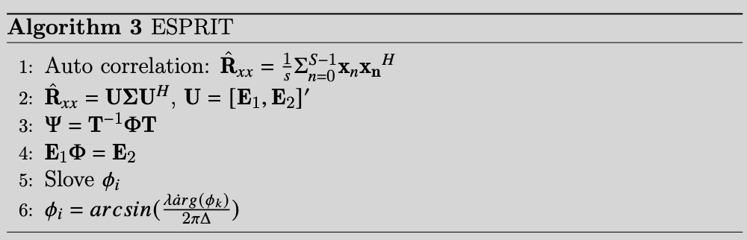

Compressive sensing
The subspace-based DoA estimation is targeted to uncorrelated and weak correlated signals. Although the subspace-based methods are easy to implement, they have extensive computation, which is not very practical for real-time processing. Moreover, the above techniques’ DoA resolution is usually limited by their array antenna spacing, which should not exceed half wavelength. Recently, with the rise of compressed sensing (CS), some scholars have applied this newly developed method to DoA estimation. Take MIMO radars as an example; they are equipped with millimeter wave technology that offers wide bandwidth, thus achieving high-range resolution. As a result, only a small number of targets fall in the same range-Doppler bin, and thus, the targets are sparse in the DoA space.
- CS aimed to solve the problem when the signal is sparse. Let $x$ denoted as the dimension of $N×1$ signal array and let $y$ be a $M×1$ under-sampled data the result after x with CS, which
$y=Φx$ (3.21)
- where $Φ$ is random $M×N$ sensing matrix with $M<<N$. A signal is called k-sparse if the sparse signal $x$ can be formed from a basis $Ψ∈R^{N×N}$, and the coefficient vector $α$, which can be written as $x=Ψα$, and has only k ($k<<N$) nonzero-entries or k principal components. Moreover, if considering input as the sparse noisy signal, the result signal $y$ in equation (3.21) can be rewritten as
$y=ΦΨα+n\left(t\right)=Θα+n\left(t\right)$ (3.22)
- where $Θ$ is a random measurement of basis function. From equation (3.22), CS can be seen as a dimensionality reduction of the signal, in which the high dimensional signal can be mapped to a lower dimension with the sensing matrix $Φ$. Therefore, the signal can be recovered by only a few random samples, which can also decrease the effectiveness of the radar structure.
- According to [18], the CS algorithm can be divided into four classes: greedy algorithm, convex relaxation algorithm, thresholding algorithm, and Bayesian approach. In recent years, various types of CS algorithms have been used to reconstruct the sparse noisy signal. The greedy and convex relaxation algorithms are the most used optimization algorithms for CS. These two commonly seen CS techniques will be applied to DoA and will be further discussed. The greedy algorithm is by selecting the locally optimal choice in every stage. Therefore, the signal $y$ is projected to $Θ$, and only the large projection coefficients are preserved. The optimization problem can be stated as
$\begin{matrix}\min_{x} & ||y-Φx{||}_{2}^{2} \\ \text{s.t.} & ||α{||}_{0}≥k\end{matrix}$ (3.23)
- Some greedy algorithms are orthogonal matching pursuit (OMP), and CoSaMP, etc.
- Another method is the convex relaxation algorithm, which computes convex optimization through conditional $l_{0}/l_{1}$-minimization for the estimation of $α$. Take $l_{1}$-minimization problem as an example; it can be stated as
$\begin{matrix}\min_{x} & ||α{||}_{1} \\ \text{s.t.} & ||y-Φx{||}_{2}^{2}<ε \\ & or \\ \min_{x} & \frac{1}{2}|\left|y-Φx{||}_{2}^{2}+λ\right||α{||}_{1}\end{matrix}$ (3.24)
- To apply DoA with CS method, the array model needed to be stated first. Considering a uniform linear array, the received signal can be represented as
$x=Σ_{k=1}^{K}s_{k}a\left(θ_{k}\right)+n\left(t\right)$ (3.25)
- where $s_{i}$ is the amplitude of the transmitted signal, $a\left(θ_{i}\right)$ is the steering vector with $θ_{i}$ is the direction of arrival from the targets, and n is the Gaussian noise. If there are $K$ targets, then reform equation (3.25) with noises as
$x=AS+n$ (3.26)
- where $A$ is the steering matrix with $N×K$ dimension. Next, assume scanning in $L$ different directions, then equation (3.26) can be written as
$x=A_{Ψ}S_{α}+n$ (3.27)
- where $A_{Ψ}∈R^{N×L}$ is the steering matrix covering the scanning region, and $S_{α}∈R^{L×1}$ is the signal amplitude. Assume $S_{α}$ is $k$-sparse signal, whose entries are $s_{i},i=1,…,K$, where the total number of k positions appeared during a direction of scanning. Apply equation (3.27) to (3.21), and the equation will be as
$y=Φx=A_{Θ}S_{α}+n$ (3.28)
- Compare equation (3.28) with (3.22), $A_{Θ}$ can be seen as a randomly sampled basis function while $S_{α}$ can be seen as the corresponding amplitude of the signal. Use Take $l_{1}$-minimization problem as an example; because $A_{Θ}$ is randomly chosen, the goal aims to estimate $S_{α}$.
- With these DoA values, calculating the position of the source or the angle of the position of the source relative to the array can be more manageable. However, in practice, DoA estimation is often complicated by the fact that there will be multiple and unknown numbers of source signals impinging on the receiver array simultaneously, with unknown amplitudes, or the background noises are large.

Conclusion
Some of the typically used radars are introduced in this tutorial to give a closer look at how they can be utilized. For example, the pulse radar is often used for distance measurement; CW radar can detect the target velocity, while the FMCW and MIMO radar can have information on both distance and velocity, with MIMO having more precise values. Moreover, to localize the multiple targets with more detailed information, DoA is described to estimate the angles of the targets. Among different techniques, Capon’s beamformer is the easiest but adequate to be used in real-life situations. MUSIC algorithm is the most popular; however, the number of targets is needed to know beforehand. With the rise of compressed sensing (CS), more DoA estimation methods have applied this technique.
In the future, how to apply the DoA estimation to the massive MIMO or other newly developed radar systems is needed to be discovered. Furthermore, the method of accurate and less time-consuming algorithms is also a challenge that needs to be studied.

References
[1] Scheer, Jim, and William A. Holm. Principles of modern radar. Edited by Mark A. Richards, and William L. Melvin. Vol. 1. Raleigh, NC, USA: SciTech Pub., 2010.
[2] "INTRODUCTION TO RADAR SIGNAL PROCESSING", Christos Ilioudis, https://udrc.eng.ed.ac.uk/sites/udrc.eng.ed.ac.uk/files/attachments/Introduction%20Radar%20signal%20processing.pdf
[3]“Continuous Wave Radar,” radartutorial.eu, https://www.radartutorial.eu/02.basics/Continuous%20Wave%20Radar.en.html.
[4]Will, Christoph, Kilin Shi, Sven Schellenberger, Tobias Steigleder, Fabian Michler, Robert Weigel, Christoph Ostgathe, and Alexander Koelpin. "Local pulse wave detection using continuous wave radar systems." IEEE Journal of Electromagnetics, RF and Microwaves in Medicine and Biology 1, no. 2 (2017): 81-89.
[5]Kim, Youngwook, and Brian Toomajian. "Hand gesture recognition using micro-Doppler signatures with convolutional neural network." IEEE Access 4 (2016): 7125-7130.
[6]Zhan, Felix. "Hand gesture recognition with convolution neural networks." In 2019 IEEE 20th international conference on information reuse and integration for data science (IRI), pp. 295-298. IEEE, 2019.
[7]"The fundamentals of millimeter wave radar sensors (Rev. A)", TI, https://www.ti.com/lit/spyy005.
[8] "Frequency-Modulated Continuous-Wave Radar (FMCW Radar)", radartutorial.eu, https://www.radartutorial.eu/02.basics/Frequency%20Modulated%20Continuous%20Wave%20Radar.en.html
[9] Ahmad, Adeel, June Chul Roh, Dan Wang, and Aish Dubey. "Vital signs monitoring of multiple people using a FMCW millimeter-wave sensor." In 2018 IEEE Radar Conference (RadarConf18), pp. 1450-1455. IEEE, 2018.
[10] Alizadeh, Mostafa, George Shaker, João Carlos Martins De Almeida, Plinio Pelegrini Morita, and Safeddin Safavi-Naeini. "Remote monitoring of human vital signs using mm-wave FMCW radar." IEEE Access 7 (2019): 54958-54968.
[11] Z. Peng, C. Li, J. -M. Muñoz-Ferreras and R. Gómez-García, "An FMCW radar sensor for human gesture recognition in the presence of multiple targets," 2017 First IEEE MTT-S International Microwave Bio Conference (IMBIOC), Gothenburg, Sweden, 2017, pp. 1-3, doi: 10.1109/IMBIOC.2017.7965798.
[12] Wang, Yong, Shasha Wang, Mu Zhou, Qing Jiang, and Zengshan Tian. "TS-I3D based hand gesture recognition method with radar sensor." IEEE Access 7 (2019): 22902-22913.
[13] Lien, Jaime, Nicholas Gillian, M. Emre Karagozler, Patrick Amihood, Carsten Schwesig, Erik Olson, Hakim Raja, and Ivan Poupyrev. "Soli: Ubiquitous gesture sensing with millimeter wave radar." ACM Transactions on Graphics (TOG) 35, no. 4 (2016): 1-19.
[14] Lei, Wentai, Xinyue Jiang, Long Xu, Jiabin Luo, Mengdi Xu, and Feifei Hou. "Continuous gesture recognition based on time sequence fusion using MIMO radar sensor and deep learning." Electronics 9, no. 5 (2020): 869.
[15] Smith, Josiah W., Shiva Thiagarajan, Richard Willis, Yiorgos Makris, and Murat Torlak. "Improved static hand gesture classification on deep convolutional neural networks using novel sterile training technique." Ieee Access 9 (2021): 10893-10902.
[16] Chen, Zhizhang, Gopal Gokeda, and Yiqiang Yu. Introduction to Direction-of-arrival Estimation. Artech House, 2010.
[17] Schmidt, Ralph. "Multiple emitter location and signal parameter estimation." IEEE transactions on antennas and propagation 34, no. 3 (1986): 276-280.
[18] Guo, Xin, and Hongbo Sun. "Compressive Sensing for target DOA estimation in radar." In 2014 International Radar Conference, pp. 1-5. IEEE, 2014.

